The Sid Anderson, (WA4MBS) Random Wire tuner
ARWT Tunable for 20, 40, ,17,15 meters
Assembly instructions by William L. Steo, (K4FZE)

Materials:
Qty.

1 --- Wooden board ¾” thick x 5 ½” w x 24” long
1 --- Piece of #14 bare copper wire 12 feet in length
1 --- 1 ½ inch PVC pipe 12 inches in length
4 --- Small alligator clips
4 --- Pieces of #16 gauge insulated wire cut to these lengths, 16 ft., 32ft., 64 ft. and 26 ft.
1 --- Air variable capacitor 320 pf
1 --- Piece of sheet metal approximately 2” wide by 3” long to be used as a ground plate to
mount the air variable capacitor. (Other methods may be used for mounting)
1 --- Non-conductive knob to fit the capacitor shaft
1 --- Antenna insulator ½ inch wide cross section of PCV pipe is adequate.
4 --- Stick on rubber feet
1 --- Piece 24 inches long of RG58U coax cable with a male PL259 connector attached
at one end
1 --- UHF female to UHF female adapter
3 --- Surface mount cable strain relief clips
2 --- *** Disk capacitors with one alligator clip (these would only be used if more capacitance is needed beyond the range of the variable capacitor).

--- Assorted wood screws and small mounting bolts and nuts as needed.
--- Antenna analyzer for tuning the ARWT.

Tools needed;

Soldering iron, solder
Screw driver
Drill bits
Electric drill
Wire stripper/cutter
Long nose pliers
Various nuts, bolts, washers, screws by individual’s choice
Wire terminals various by choice

The following directions are not a step by step procedure but rather a basic overview so that each individual may slightly modify the design to fit their needs and use their available materials list.

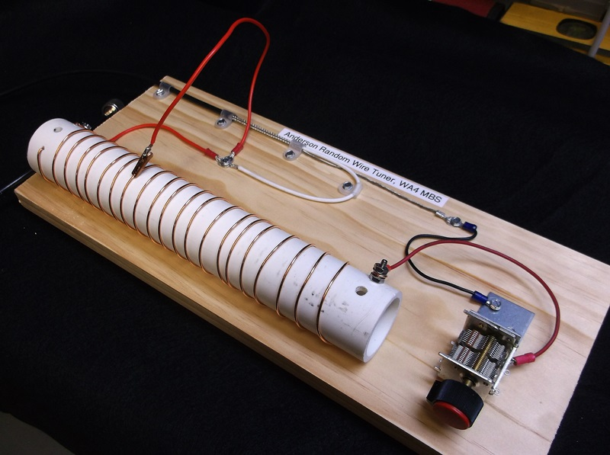
This is how the finished product will look. Ground radials and antenna wire not attached.

Construction suggestions;

1. Drill two ¼ inch screw access holes on opposite ends of the PVC pipe ½ inch from the ends
and drilling only through one wall of the pipe.

2. Using the ¼ inch screw holes as a guide drill a 1/8” hole through the opposite wall of the pipe,
(180 degrees from the ¼” hole). These smaller holes will house the pipe mounting screws that
affix the pipe to the board.

3. From a 12 foot piece of Romex 14-2 gauge wire remove the bare ground wire to be used
as the coil.

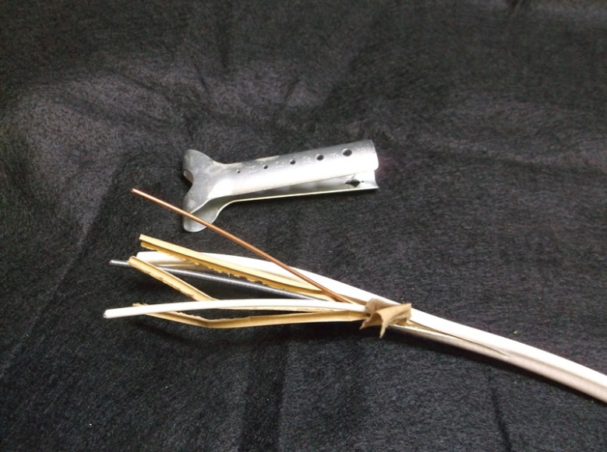
Romex jacket (insulation) cutter makes the removal of the ground wire fairly easy.

4. When wrapping the wire around the PVC pipe it is easier to drill two small holes on both sides
of the pipe first, then insert the wire through the holes and attached the end to the pipe with a
screw. This will hold that end of the wire in place as the turns are made.

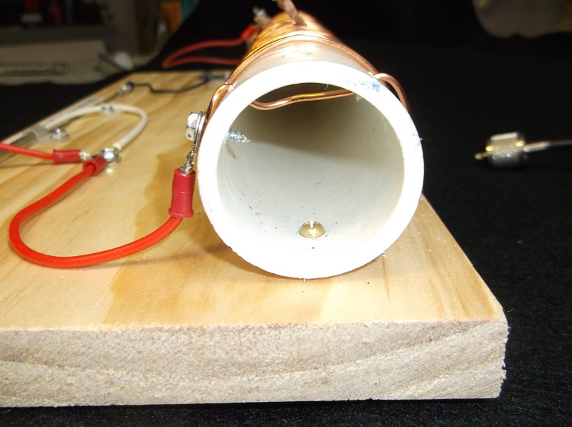

5. Once the coil is completed, construct the terminal at the capacitor end of the pipe as shown.

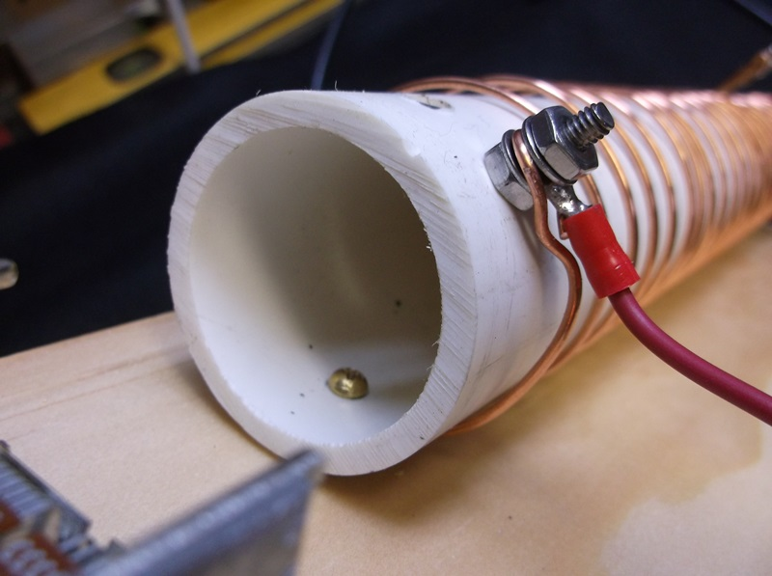

6. Before mounting the coil-pipe assembly to the board be sure the spacing between the windings of wire are approximately ½ inch apart from each other.

7. Mount the pipe-coil assembly to the board with wood screws. This will prevent the coil from
shifting along the PVC pipe. The assembly is shown below without the coil for demonstration
purposes.

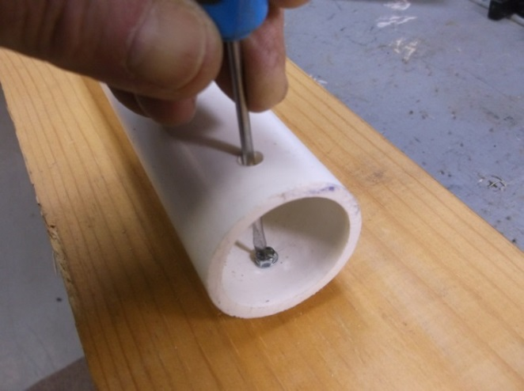

8. Complete all other connections as shown in the next two photos. Using the smaller section of the capacitor will allow for a slower more precise tuning than the larger section. Both sections should be explored when test and tuning the AWRT.

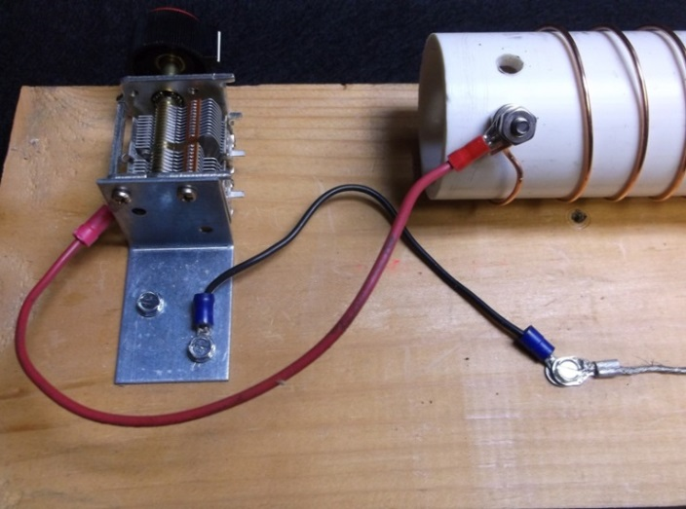

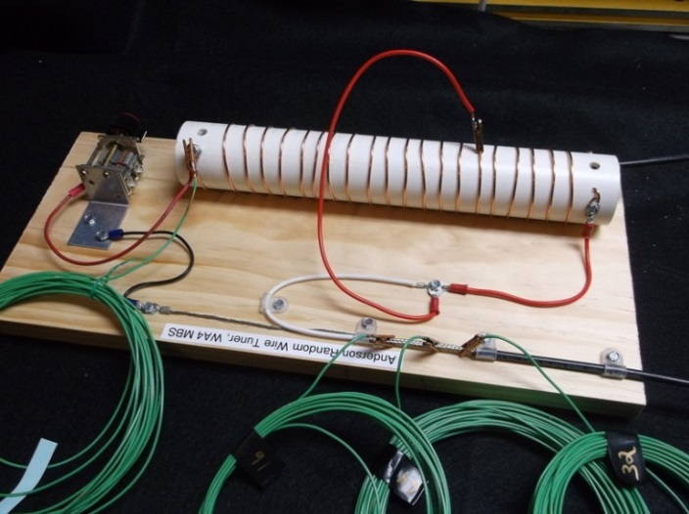

Testing notes.

1. The radiating element wire (26 ft.) can be strung at any angle.

2. Ground radial wires (16, 32, 64 ft.) may be laid on the ground in any direction.

3. A strain relief stake is need near the AWRT to take the strain off the antenna connection at the PVC pipe, (meaning he connection at the capacitor end of pipe see diagram below).

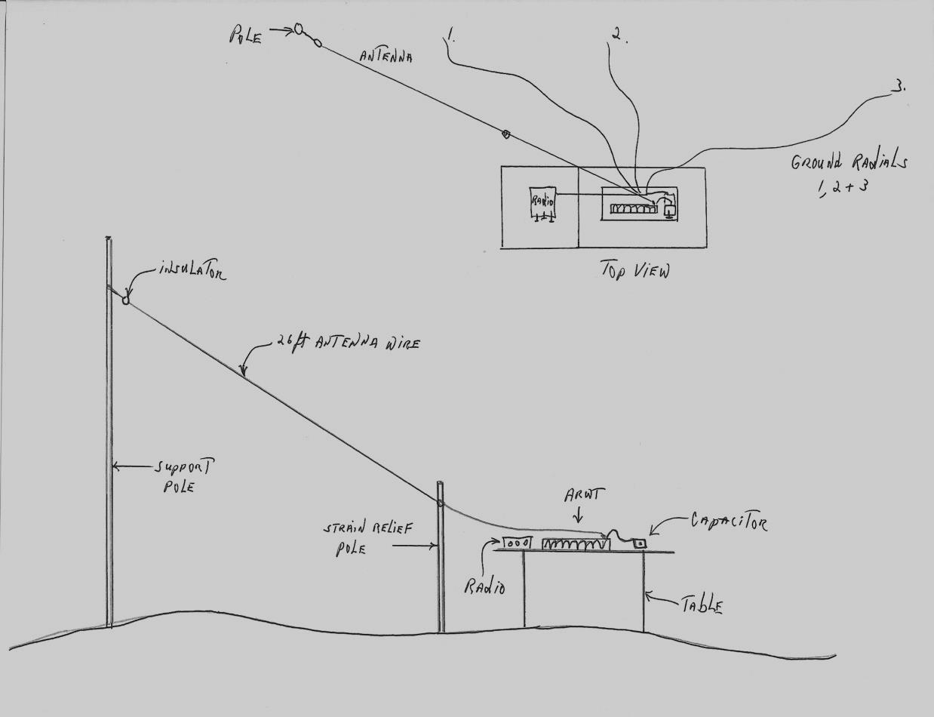

10. The bands that will tune using the ARWT are 40, 20, 17 and 15 meters. When testing
the AWRT the red jumper wire with the alligator clip should tune the 20 meter band
somewhere near the sixth coil of the wire. This position may vary with the band selected.
Be sure to move the variable capacitor knob slowly while watching the SWR meter on an
antenna analyzer.

11. Once the ARWT is tuned to a particular band it will hold that tune across the entire band
width.

